**High Pass Filter**

**LAB # 11**

** Fall 2019**

**Fall 2021**

**CSE202L Circuit system-II**

Submitted by: **Ashfaq Ahmad**

Registration No: **19PWCSE1795**

Class Section: **B**

“On my honor, as student of University of Engineering and Technology, I have neither given nor received unauthorized assistance on this academic work.”

Student Signature: ______________

Submitted to:

**Engr. Faiz ullah**

February 9 , 2021

**Department of Computer Systems Engineering**

**University of Engineering and Technology, Peshawar**

**High Pass Filter**

It is a frequency selective circuit, which passes signals of frequencies above its low cut off frequency (fL) and attenuates signals of frequencies below fL.

**Objectives:**

To study the Active High pass filter and to evaluate:

* Low cutoff frequency of High pass filter.
* Pass band gain of High pass filter.
* Plot the frequency response of High pass filter.

**Equipment:**

1. DC power supplies +15V, −15V from external source
2. Function generator
3. Oscilloscope
4. Digital Multimeter

**Components:**

1. Resistance 10kΩ
2. Resistance 22kΩ
3. Capacitor 0.01µF
4. LM 741

**Equation of High pass filter**

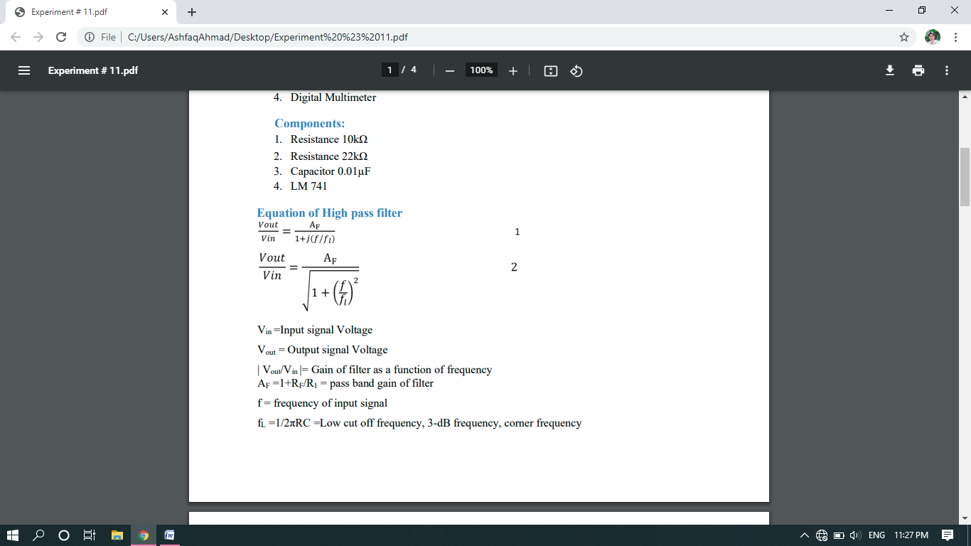

Vin =Input signal Voltage

Vout = Output signal Voltage

| Vout/Vin |= Gain of filter as a function of frequency

AF =1+RF/R1 = pass band gain of filter

f = frequency of input signal

fL =1/2πRC =Low cut off frequency, 3-dB frequency, corner frequency

Operation of high pass filter using equation 2

1. At low frequencies f < fL: | Vout/Vin | < AF
2. At f=fL | Vout/Vin | =0.707*AF(Approx.)
3. At f > fL | Vout/Vin | = AF

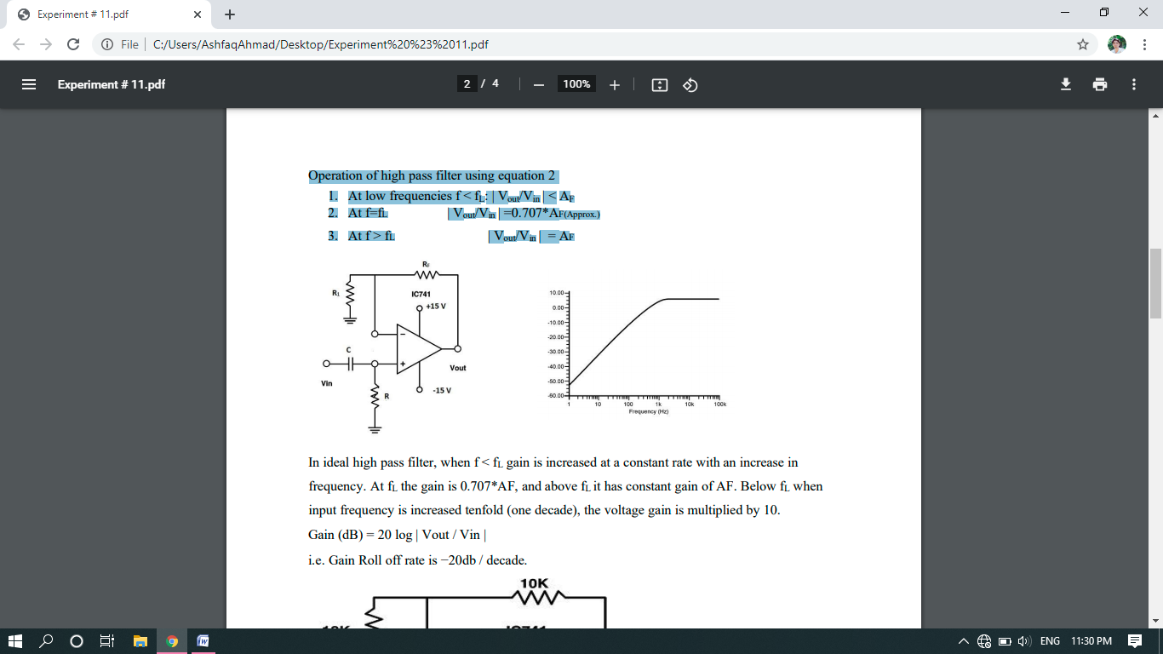

In ideal high pass filter, when f < fL gain is increased at a constant rate with an increase in frequency. At fL the gain is 0.707*AF, and above fL it has constant gain of AF. Below fL when input frequency is increased tenfold (one decade), the voltage gain is multiplied by 10. Gain (dB) = 20 log | Vout / Vin |

i.e. Gain Roll off rate is −20db / decade.

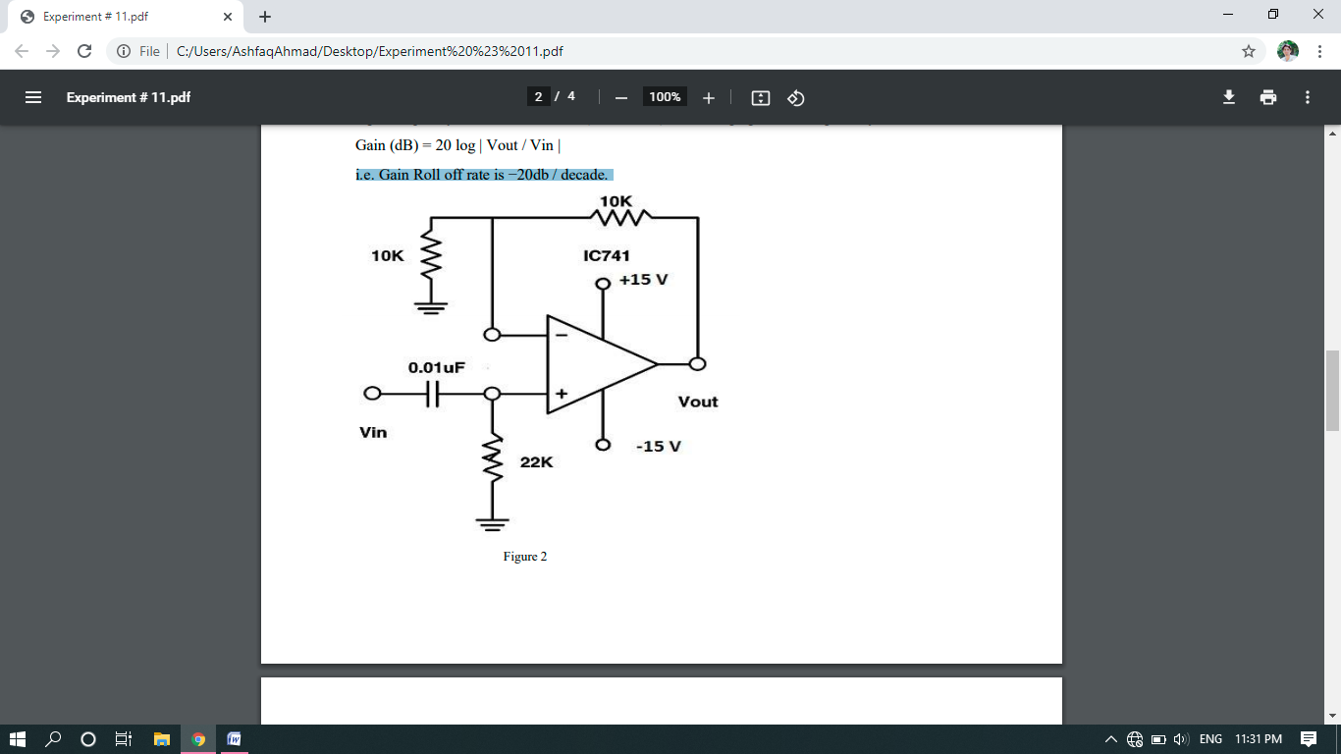

Procedure:

1. Connect the circuit as shown in Figure 2.
2. Switch ON the power supply.
3. Connect a sinusoidal signal of amplitude 1V (p-p) of frequency 1KHz to Vin of High pass filter from function generator.
4. Connect Ch-1 of oscilloscope to the signal source.
5. Observe output on Ch-2 of oscilloscope.
6. Increase the frequency of input signal step by step and observe the effect on output Vout on oscilloscope.
7. Tabulate values of Vout, gain, gain (dB) at different values of input frequency shown in observation Table 2.
8. Plot the frequency response of High pass filter using the data obtained at different input frequencies.

**Theoretical Calculations:**

Calculate all the following values

1. Pass band gain of High pass filter AF = 1 + RF / R1
2. Pass band gain (dB) = 20 log |Vout / Vin|
3. Low cutoff frequency fL = 1/2πRC
4. Gain at Low cutoff frequency fL = 0.707 * AF
5. Roll off rate = −20db/decade

**Experimental Picture:**

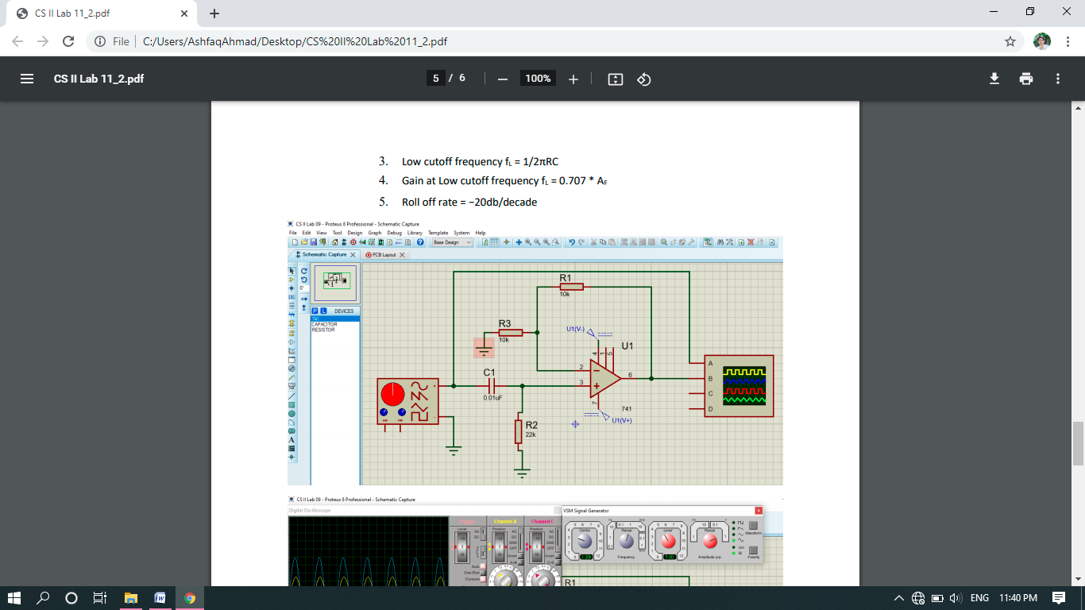

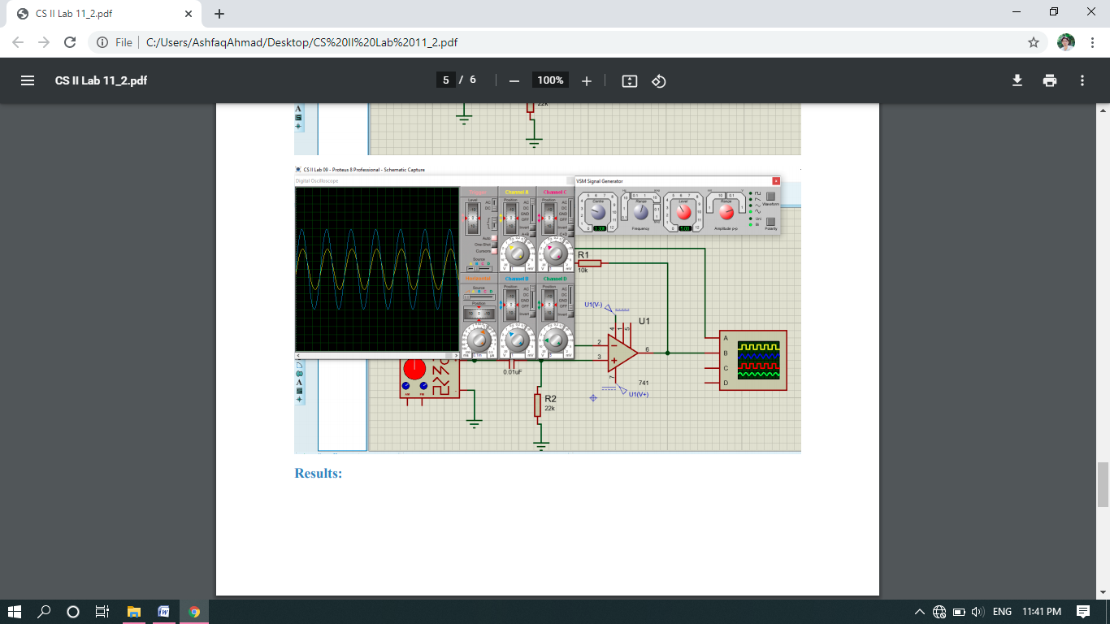

**Results:**

|  |  |  |
| --- | --- | --- |
|  | theoretical | practical |
| pass band gain (Ar) | **2** | **2** |
| pass band gain (Ar) in db | **6.02** | **6.02** |
| 3 db frequency fr | **701.43Hz** | **703 Hz** |
| Gain at 3db frequency (fl) in db | **1.41** | **2.32** |

**Table 1**

|  |  |  |  |  |
| --- | --- | --- | --- | --- |
| S No | Input frequency (Hz) | Vout | |Vout/vin|=Gain | Gain (db)=20 log |vout/vin| |
| 1 | **300** | **3.83** | **0.766** | **-2.31** |
| 2 | **500** | **5.70** | **1.14** | **1.13** |
| 3 | **700** | **7** | **1.4** | **2.92** |
| 4 | **1k** | **8** | **1.6** | **4.08** |
| 5 | **5k** | **9.9** | **1.98** | **5.9** |
| 6 | **10k** | **10** | **2** | **6.02** |
| 7 | **15k** | **10** | **2** | **6.02** |

**Table 2**

**The End**